AP ART HISTORY
Summer Assignment: Prehistoric Art

Background information to consider: There is so little known about the context of each prehistoric work of art that much of what experts say is speculation. So use intelligent conjecture to answer the questions regarding the work.
Part One: Getting to know the work of art
Directions: Look at the two works below. Complete the chart regarding each work
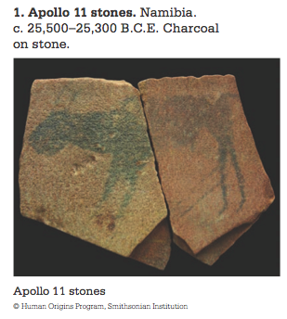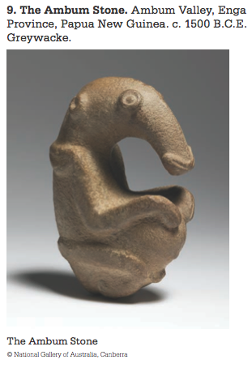

TITLE OF WORK | FORMAL ELEMENTS  (line, color, mass, composition, space, medium etc) | FORM | FUNCTION | CONTENT | CONTEXT

Part Two: Writing about the art
Directions: in the space below write a paragraph about each work. Speculate on how and why it was made (use both visual and contextual evidence)
Visual Evidence: Evidence gathered from viewing/looking at the work of art.
Contextual Evidence: Evidence gathered from videos, readings, or research on a work of art.
APOLLO 11 STONES:
________________________________________________________________________________________________________________________________________________________________________________________________________________________________________________________________________________________________________________________________________________________________________________________________________________________________________________________________________________________________________________________________________________________________________________________________________________________________________________________________________________________________________
________________________________________________________________________________________________________________________________________________________________________________________________________________________________________________________________________________________________________________________________________________________________________________________________________________________________________________________________________________________________________________________________________________________________________________________________________________________________________________________________________________________________________
THE AMBUM STONE:
________________________________________________________________________________________________________________________________________________________________________________________________________________________________________________________________________________________________________________________________________________________________________________________________________________________________________________________________________________________________________________________________________________________________________________________________________________________________________________________________________________________________________
________________________________________________________________________________________________________________________________________________________________________________________________________________________________________________________________________________________________________________________________________________________________________________________________________________________________________________________________________________________________________________________________________________________________________________________________________________________________________________________________________________________________________
Part Three: Art Materials
Directions: Watch the two videos – located at the following links: https://www.youtube.com/watch?v=LvhDb4phhzY & https://www.youtube.com/watch?v=2hiFqqqjTxQ and Read the attached section on LASCAUX, then answer the questions below.
- What do you think the artist used for paint? Brushes? Light?

- Why do you think Lascaux was created?

Part Four: Materials, Form & Function
Directions: Look at the following works of art and answer the following question for each of the works.
TITLE OF THE WORK | What was the reason for the materials used to create each piece? | What do you think is the relationship between the materials, the pieces form and function are?
